**Copilot Setup through Mail Invitation**

1. Users will receive the following email invitation from GitHub ([noreply@github.com](mailto:noreply@github.com)).



1. Click on **Join @GlobalLogic-India-Private** button or copy paste the url given at the bottom of the invitation in the default browser address bar.

*[Note: Please ensure that the below steps are performed in the user’s default web browser. This will simply*

*the Copilot sign in process]*

**

1. Once the page is loaded, create a github account with GL email id. Enter the preferred username, email address(mention global logic email id) and the password. Once the form is completed, click **Create Account and join** Button.

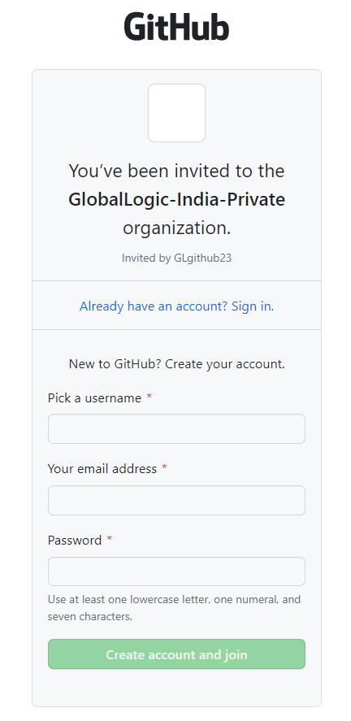

1. A new window will appear asking the user to verify the account. Follow the instructions to verify the account and Click the **Join a free plan** button.

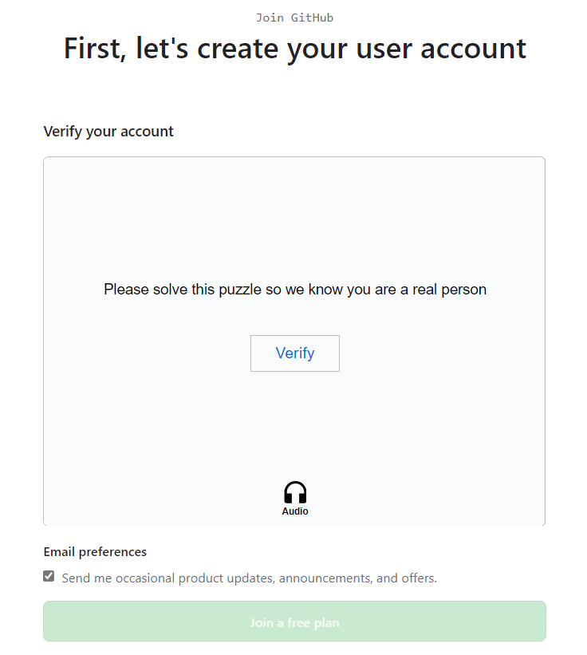

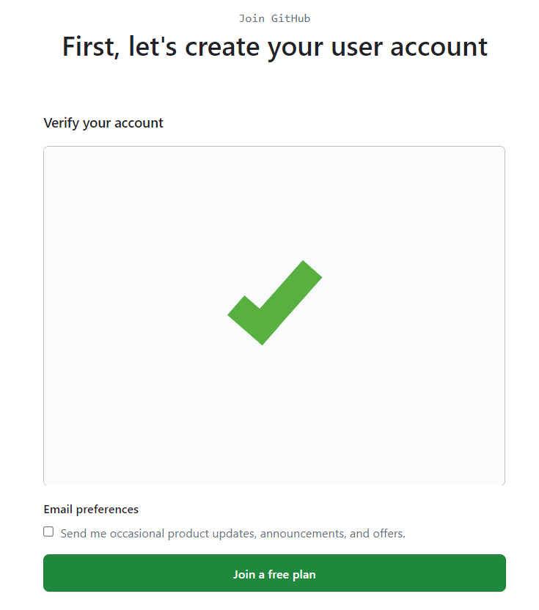

1. The below invitation page will be displayed.

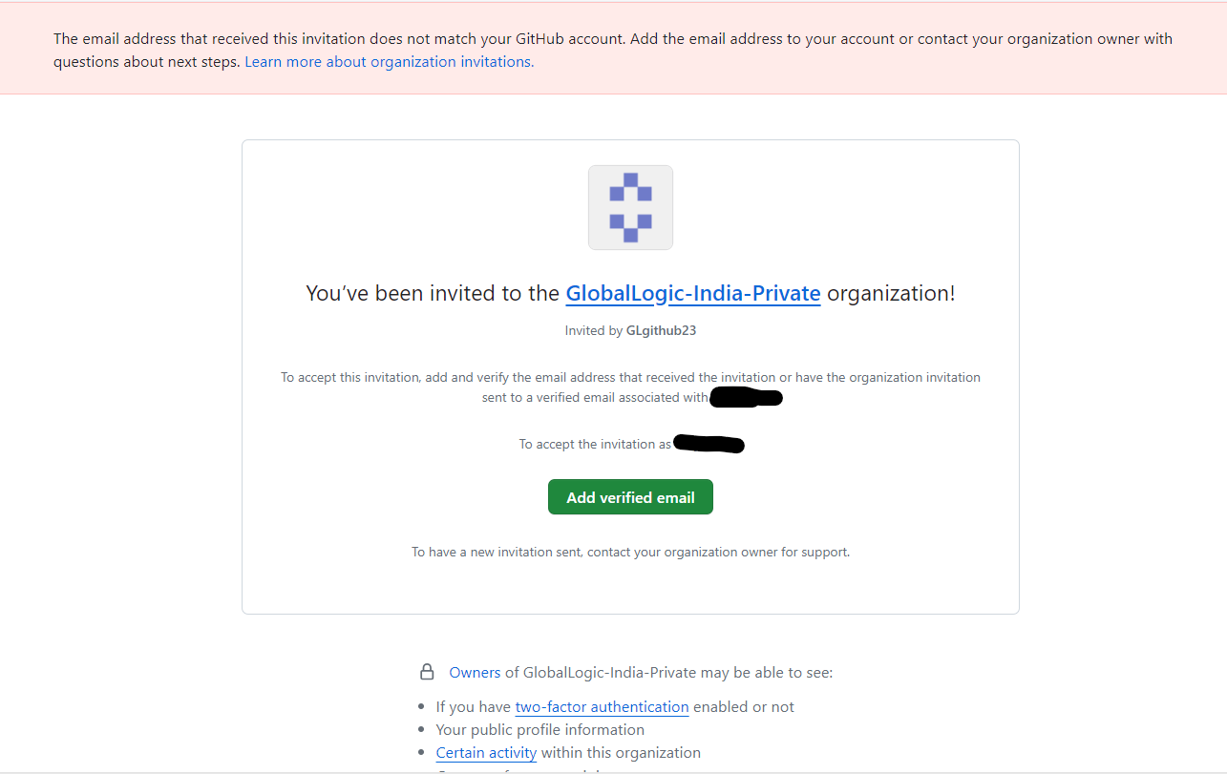

1. The user will receive a GitHub launch code over email. Click on the **Open GitHub** button in the email.

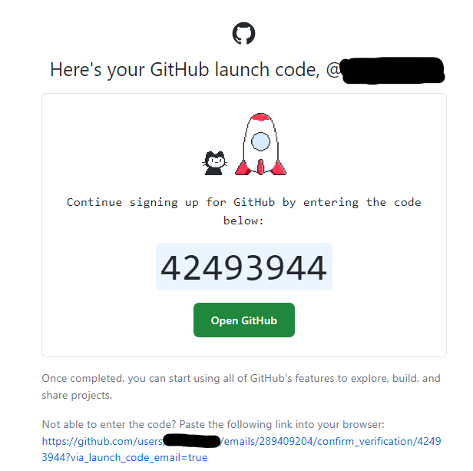

1. After clicking the Open **GitHub** button, the below page will be displayed. Enter the launch code.

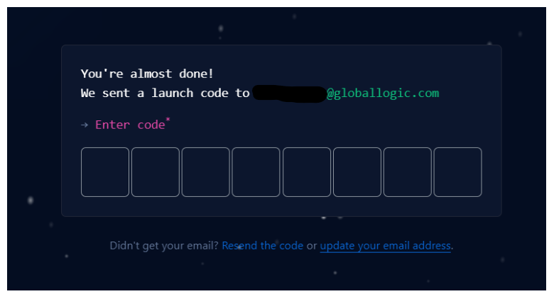

1. Once the launch code is entered and verified, users will be navigated to the GitHub account dashboard page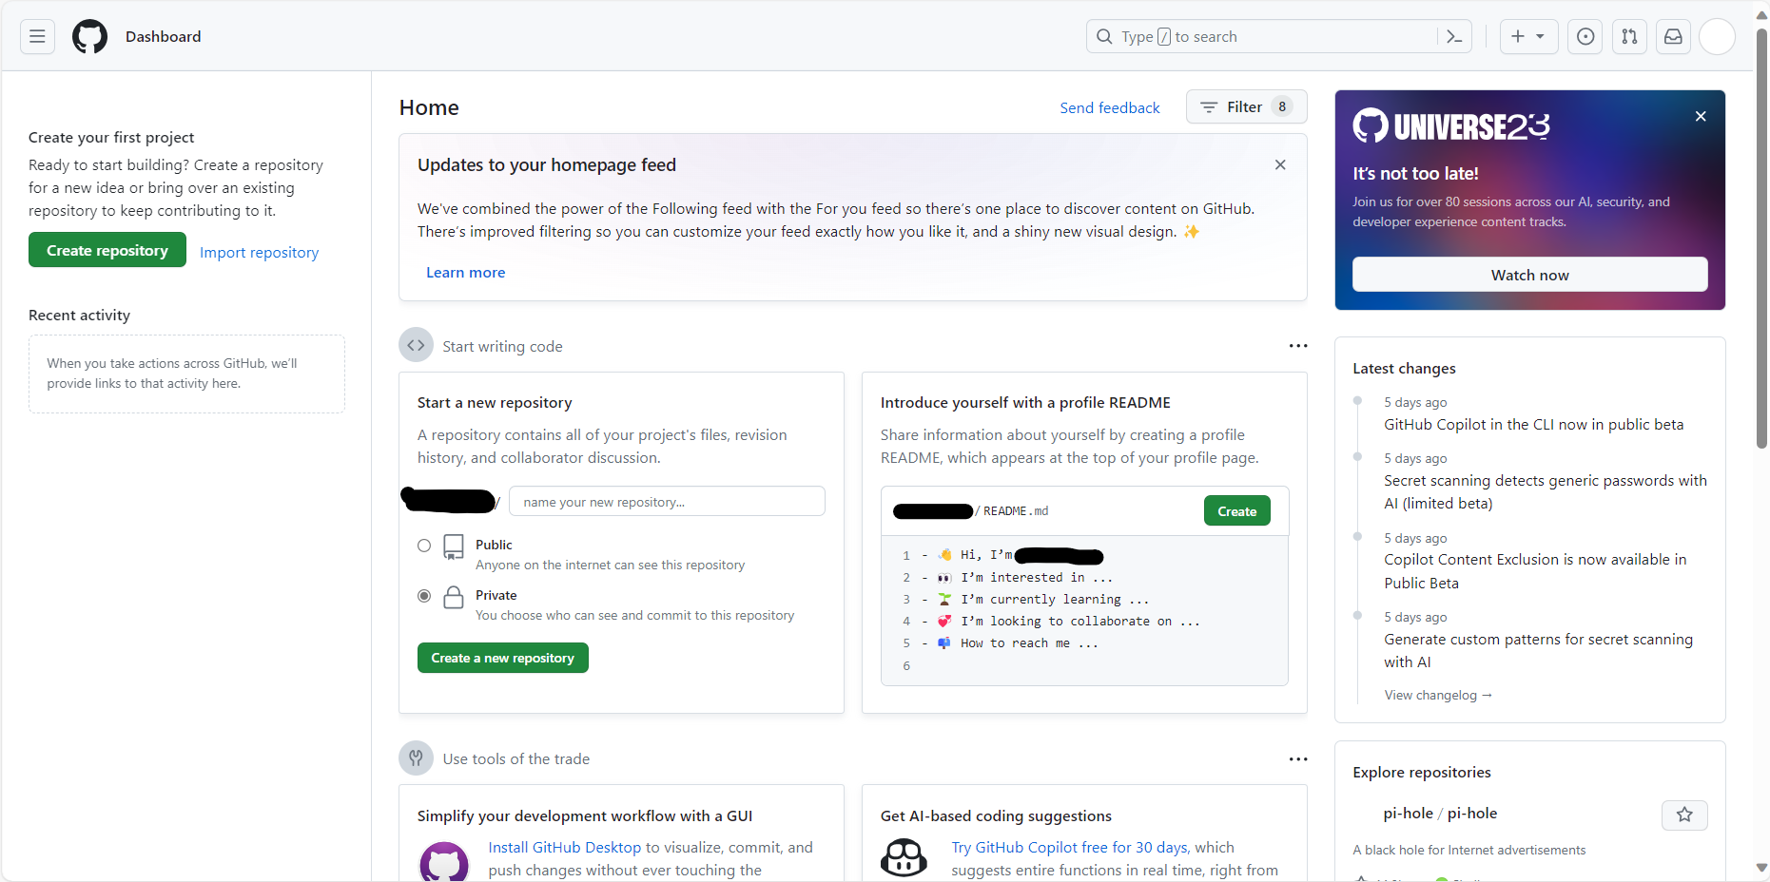
2. User will receive another email confirming the account creation.

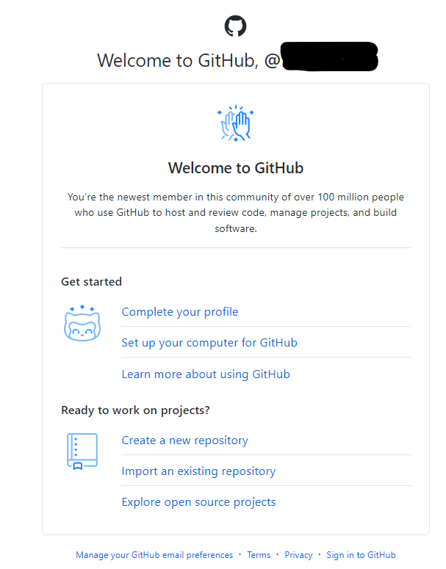

Now follow the below steps to install the extension in visual studio

**Steps for Installing GitHub Copilot for the Visual Studio 2022**

**STEP 1:**

In the Visual Studio menu bar, click **Extensions**, then click **Manage Extensions**.

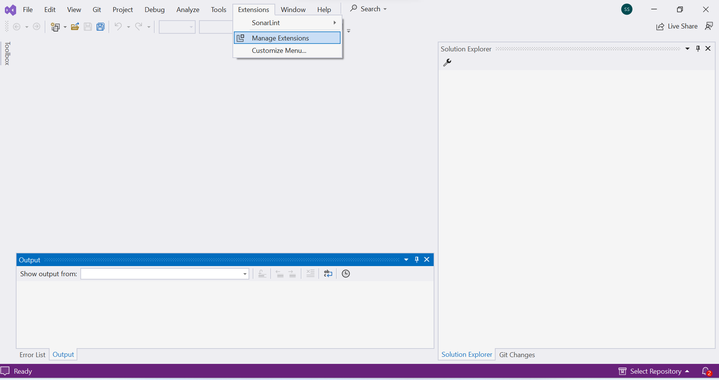

**STEP 2:**

In the "Manage Extensions" window, click **Visual Studio Marketplace**, search for the GitHub Copilot extension, then click **Download**.

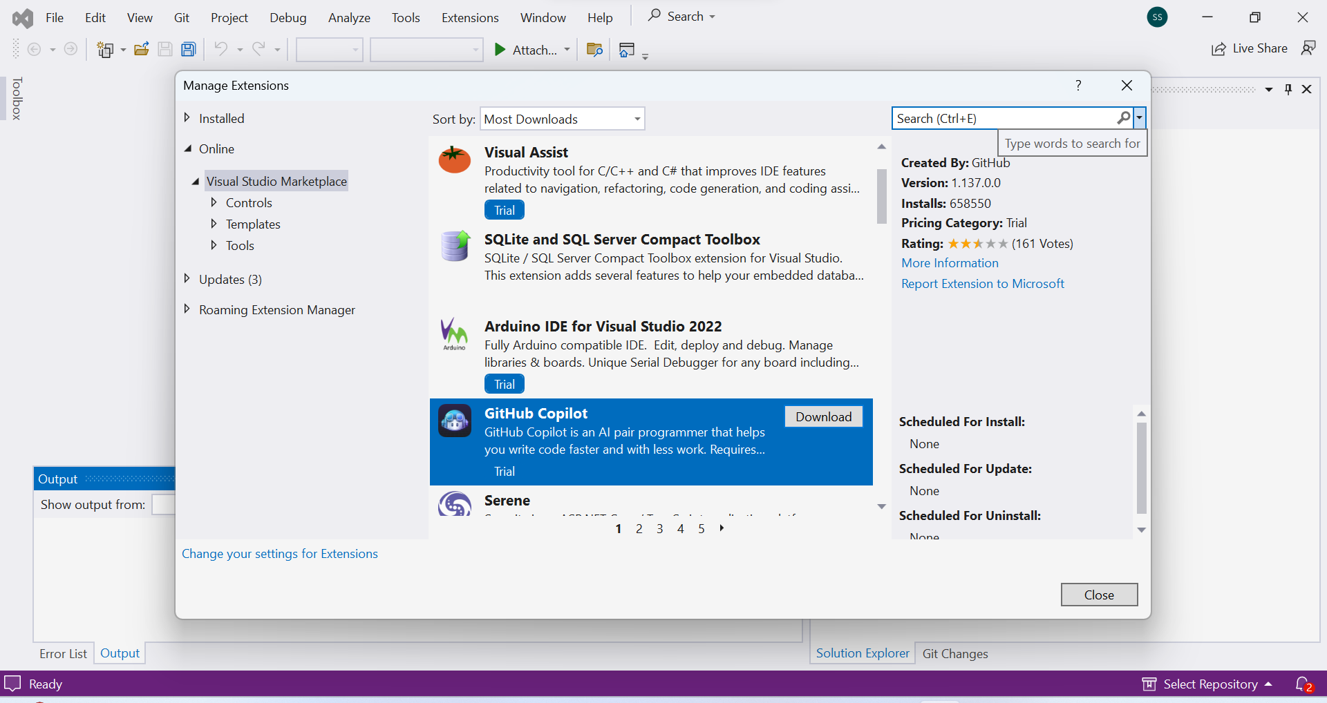

**STEP 3:**

Close the "Manage Extensions" window, then exit and relaunch Visual Studio.

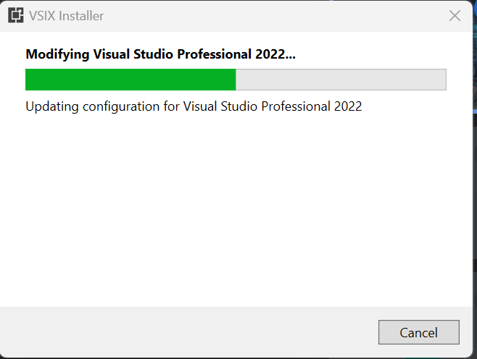

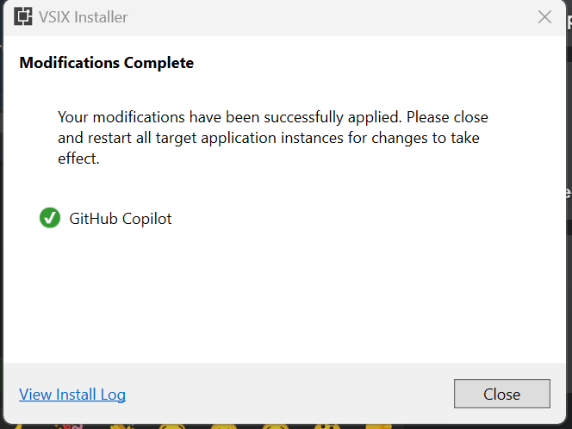

**STEP 4:**

Optionally, to check that GitHub Copilot is installed and enabled, go back to **Manage Extensions**, click **Installed** to view your currently installed extensions, then click **GitHub Copilot** to see status information.

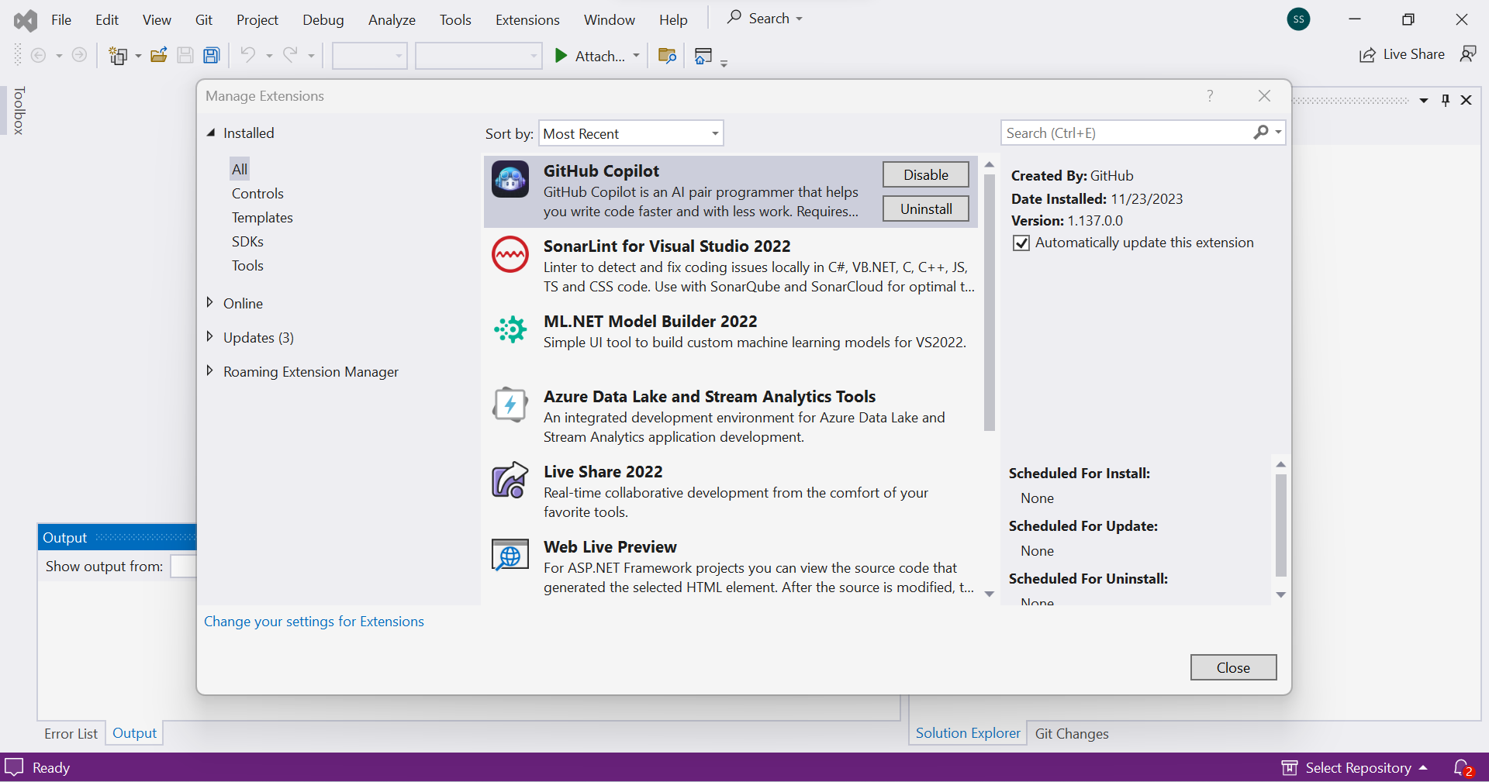

**STEP 5:**

Add your GitHub account to the visual studio in order to use the copilot. Click on the add Github Account

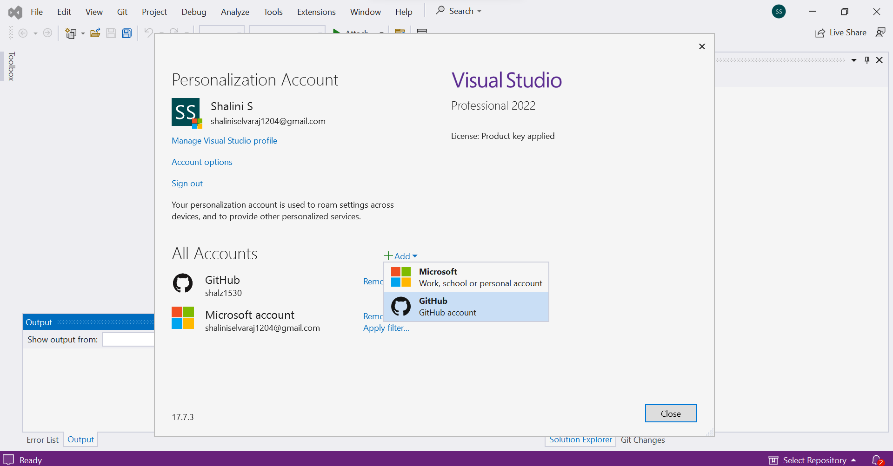

**STEP 6:**

After clicking on the add account , it directs to the webpage asking for credentials to login to GitHub account. Use the GL userid and password. After successful login, it directs to the authorize visual studio page. Click on Authorize GitHub.

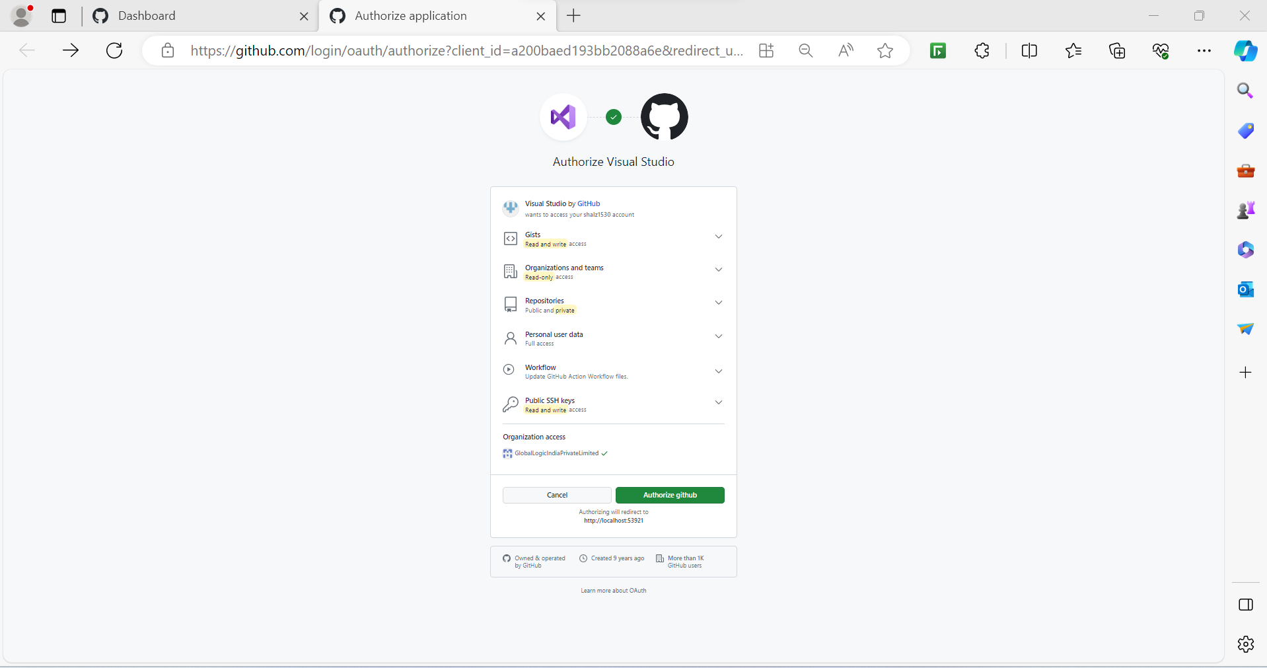

**STEP 7:**

Once the authorization is successful, you can open VS 2022.

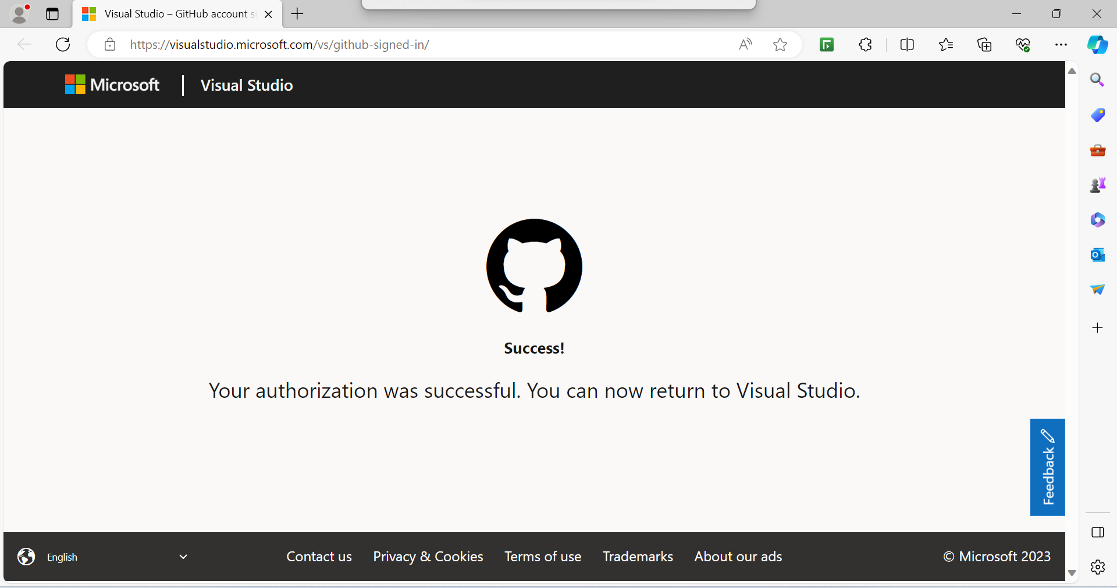

**STEP 8:**

Once you open the VS 2022, you can see your git hub account visible under the all accounts.

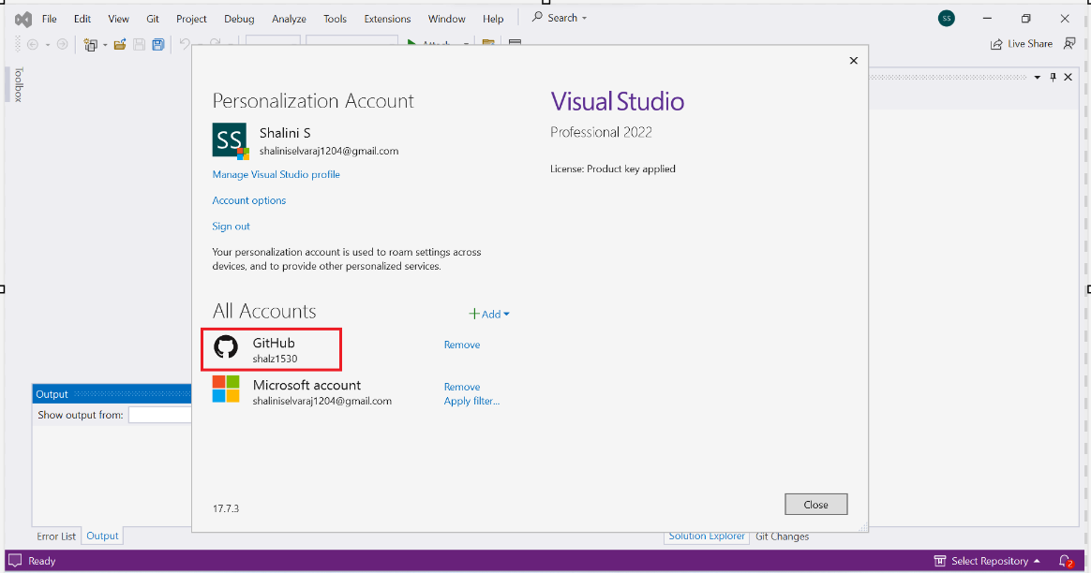

**Step 9:**

In the "Manage Extensions" window, click **Visual Studio Marketplace**, search for the GitHub Copilot chat, then click **Download** if its not downloaded already.

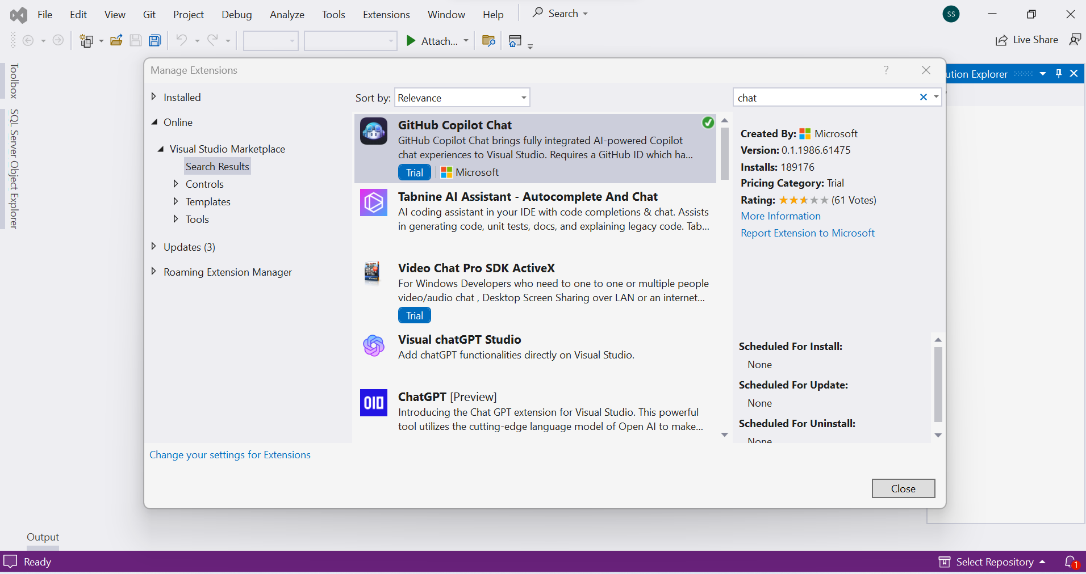

**Step 10:**

Under “View” option, you will be able to see the chat feature.

